|  |
| --- |
| EPAM Systems, RD Dep. |
| MTN.BI.07 Basic Parallel Execution |

|  |  |  |  |  |  |
| --- | --- | --- | --- | --- | --- |
| REVISION HISTORY | | | | | |
| Ver. | Description of Change | Author | Date | Approved | |
| Name | Effective Date |
| 1.0 | Initial status | [Hanna](mailto:Kiryl_Bucha@epam.com) Hul | 12-JAN-2012 |  |  |

Contents

1. Data Modeling Task 3

2. Analytical task 3

3. Results 3

# Data Modeling Task

Create samples of:

* Parallel Select

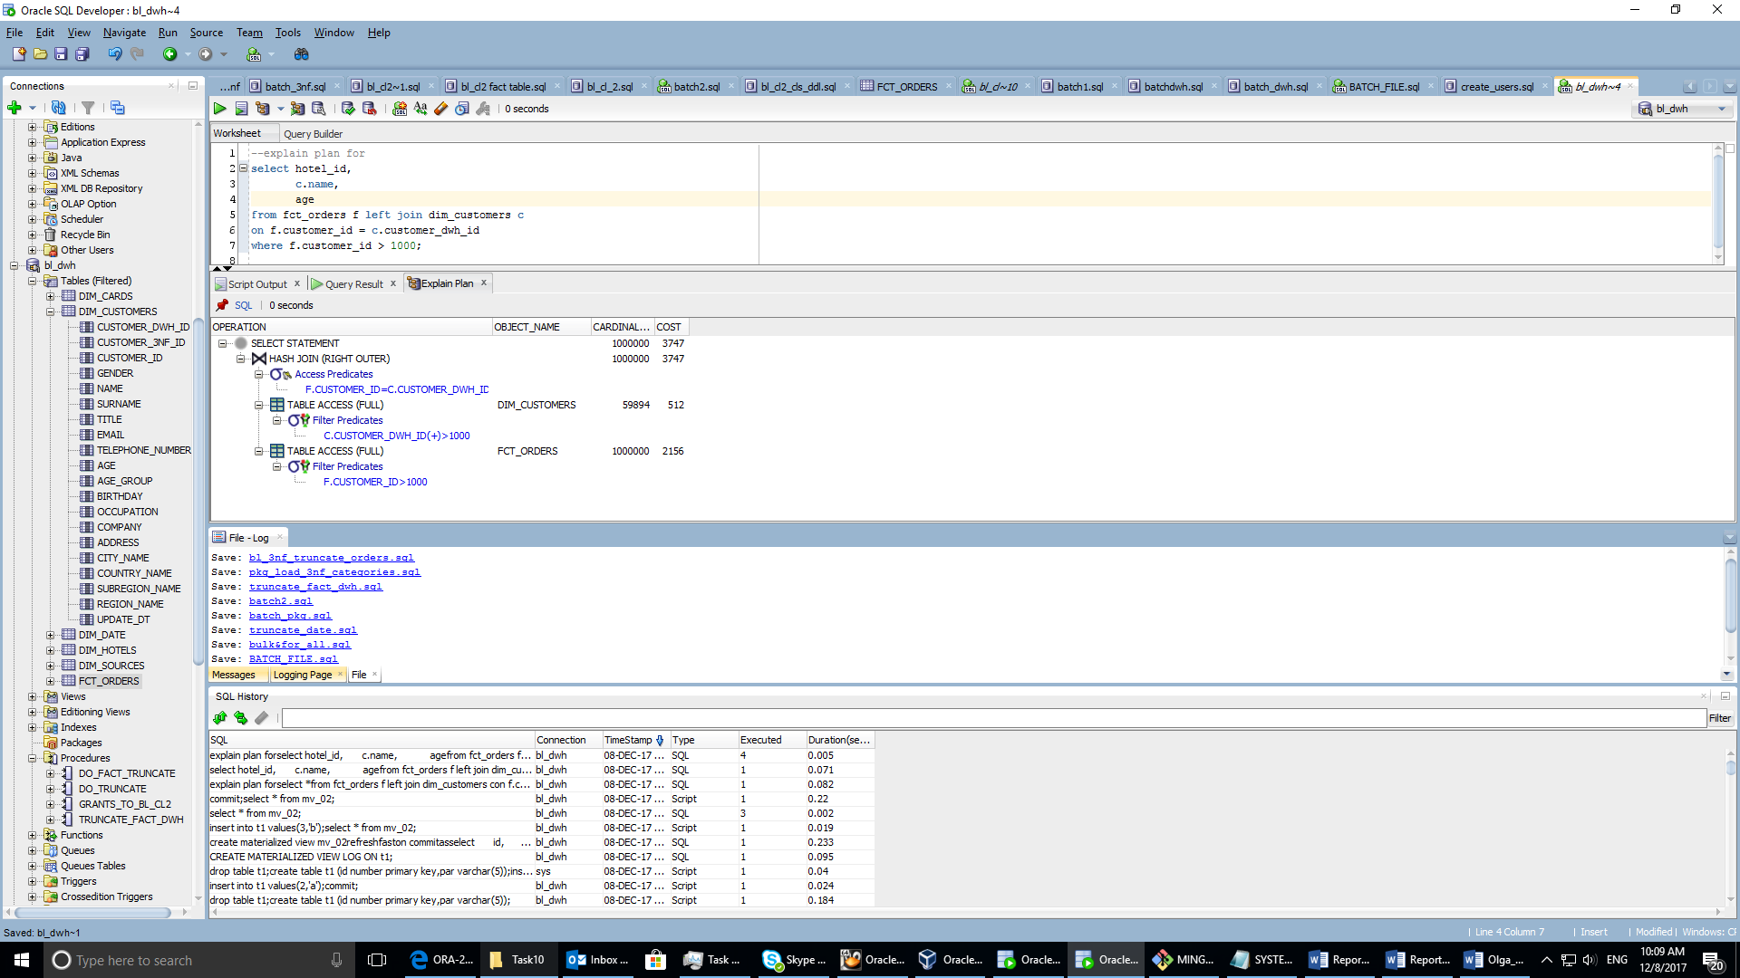

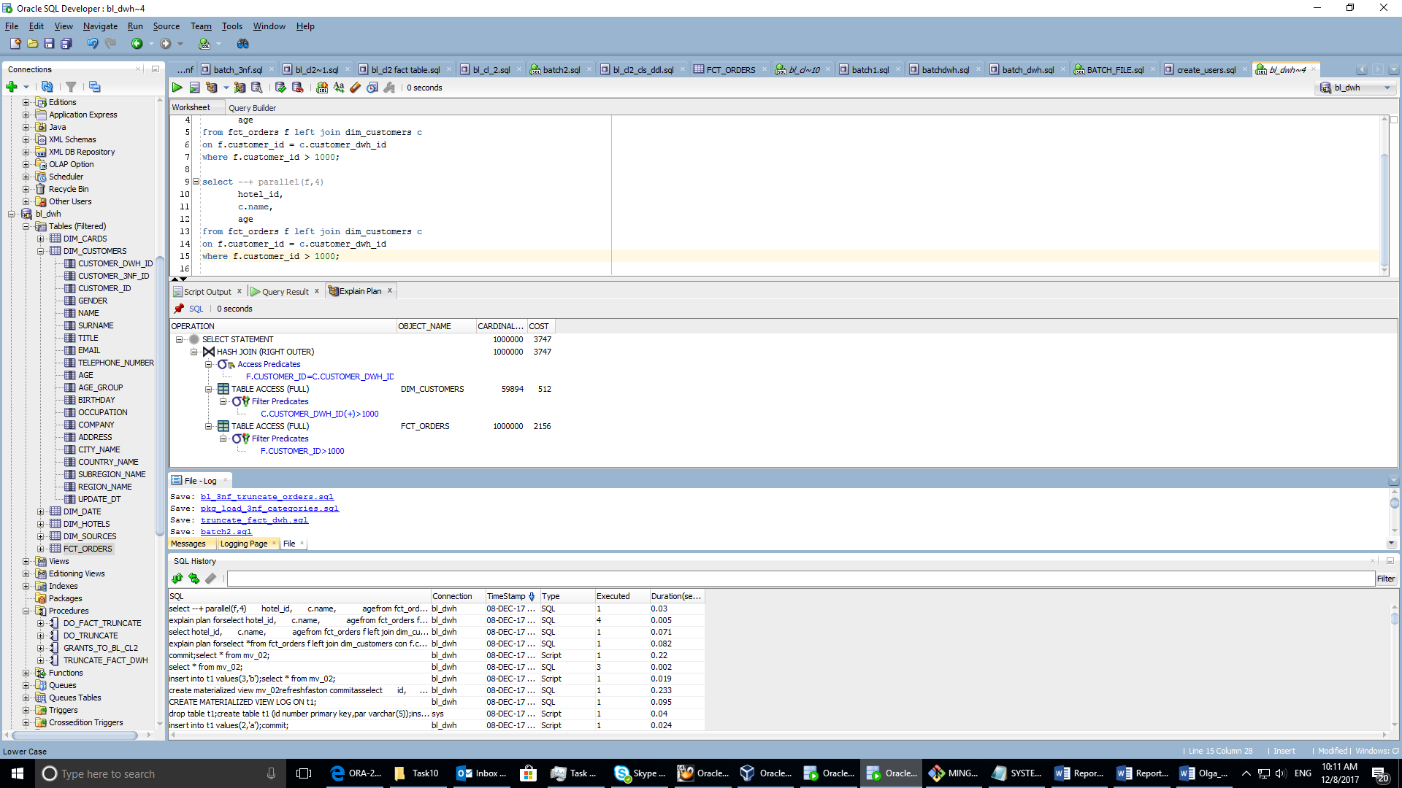

* Parallel DML